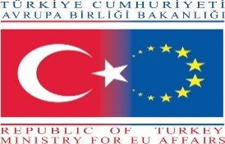 | 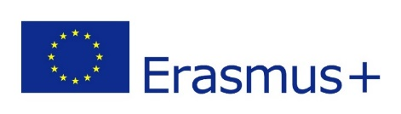 | 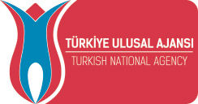

ERASMUS+
KA2 - COOPERATION FOR INNOVATION AND THE EXCHANGE OF GOOD PRACTICES
STRATEGIC PARTNERSHIPS FOR VOCATIONAL EDUCATION AND TRAINING

KEEP LAB SAFETY KEEP YOU HEALTHY

2017-1-TR01-KA202-046148

FIRST TRANSNATIONAL PROJECT MEETING (KICK-OFF MEETING) IN TURKEY (ANKARA)
ANKARA UNIVERSITY

05.02.2018

AGENDA

09:30 – 10:30 Opening and Registration

10:30 – 11:00 Opening Speeches

11:00 – 11:15 Coffee Break

11:15 – 12:30 Presentation of the Project

12:30 – 13:30 Lunch Break

13:30 – 14:30 Planning of the Project Activities and Intellectual Outputs

14:30 – 14:45 Coffee Break

14:45 – 16:00 Evaluation of the Project Budget and Planning of the Project Expenditures

16:00 – 16:30 Evaluation and Closing

